Nexus – Resident Information Guide
  - What you need to know about living at Nexus at St Leonards

02-Jul-12
The Nexus Team
contactus@nexusatstleonards.com.au www.nexusatstleonards.com.au

Table of Contents
Introduction 4
Website 4
Nexus - What you need to know about your Home 5
1. Air Conditioning - Not Working? 5
2. Car Park 5
3. Car Park Roller Door - Not Working? 5
4. CCTV (Closed Circuit Television) System 5
5. Cold Water - Not Working? 6
6. Electricity - Not Working? 6
7. Fire Control System - Emergency Evacuation 6
8. Garbage and Recycling 7
9. Hot Water - Not Working? 8
10. Intercom Operation 8
11. Junk Mail 11
12. Lift - Not Working? 11
13. Moving anything in or out or receiving a delivery? 11
14. Security Fob - Not Working? 12
15. Security System - Not Working? 12
16. Smoke Detectors 12
17. Telephone and Internet 13
18. Toilet/Sewerage - Not Working? 13
19. TV Reception - Not Working? 13
20. Utility Service Shutoff Points 14
21. Window Cleaning 14
Fire Control System 15
1. How does the Nexus Fire Control System notify an alarm? 15
2. What do you need to do when you hear an alarm and there is no apparent fire? 15
3. What do you need to do when you hear an alarm and there is fire or smoke? 16
4. What do I do in an Emergency Evacuation? 16
5. Safe Living in High Rise Buildings 16
6. Fire Safety Tips 17

Nexus at St Leonards
Building Management Committee
Residential Strata Plan 70012
Commercial Strata Plan 70013
15 Atchison Street, St Leonards NSW 2065
Email: contactus@nexusatstleonards.com.au
Website: www.nexusatstleonards.com.au

Strata Manager
Bright & Duggan Pty Ltd
Level 1, 37-43 Alexander Street, Crows Nest NSW 2065
Phone: 02-9902-7100
Fax: 02-9439-6443
Email: stratamanager@nexusatstleonards.com.au

Building Manager
Mobile: 0423-035-769
Email: buildingmanager@nexusatstleonards.com.au

Introduction
The Owners Corporation of Nexus at St Leonards welcomes you to your home and has compiled this Guide to assist you in living at Nexus.
We trust the information contained herein will aid you in familiarising yourself with the Nexus By-Laws (and the Strata Schemes Management Act 1996), your obligations and your responsibilities with regards to Nexus, use of the Facilities and Common Areas as well as assure you that your interests are of paramount importance to all of us at Nexus.

We are more than happy to assist with any enquiry you may have which can be lodged at the contacts noted on the page above.

Website
Our website, www.nexusatstleonards.com.au, sets out information relevant to Nexus and, as it is in the public domain, provides potential purchasers with an overview of our location, amenities and lifestyle.
The website is easy to use and we trust that you will find within it the necessary information to reassure you that Nexus is being managed in your best interests.
You can contact us at Nexus, the Strata Manager or the Building Manager directly from the website.

Nexus - What you need to know about your Home

Air Conditioning - Not Working?

Owners (and residents) are responsible for the operation, maintenance, repair and, where necessary, replacement of the apartment Air Conditioning Unit which exclusively services an apartment.

Procedure for an apartment to use if:
There is no Air Conditioning in an individual apartment
- Turn the Air Conditioning off at the apartment control panel, wait 10 seconds and turn on again
- Air Conditioning should now reset and be ready for use
- If this action does not reset the Air Conditioning, call the Building Manager (see page 2 for contact details) to call the Air Conditioning Company

Car Park

Most apartments enjoy the use of a private carspace in the Car Park. A list of those apartments cross matched with their apartment number is found on the Nexus website (see FAQ’s section). Each carspace is private property and parking in another carspace is trespassing on the private property of a neighbour.

Procedure for an apartment to use if:
There is someone else’s vehicle parked in your carspace
- Call the Building Manager (see page 2 for contact details) to see if the offending vehicle is on the Nexus Resident Registration list. If it is, the Building Manager will be able to contact the vehicle owner and ask them to move the vehicle

Car Park Roller Door - Not Working?

Procedure for an apartment to use if:
Roller Door is stuck open or closed for any reason
- Call the Building Manager (see page 2 for contact details) to call the Roller Door Company

CCTV (Closed Circuit Television) System

There are a number of CCTV cameras installed at Nexus for your security and safety. The cameras are wired to a digital recording system which records events 24 hours a day. The recording system can recall information if required and relevant footage can be forwarded to the relevant authorities including the Police.

Cold Water - Not Working?

Procedure for an apartment to use if:
There is no Cold Water in an individual apartment
- Call the Building Manager (see page 2 for contact details) to call the Water Company

Electricity - Not Working?

Procedure for an apartment to use if:
There is no Electricity in an individual apartment
- Check power board in your apartment and ensure that circuit breakers have not been tripped
- Call your Electricity retailer to ensure you have supply
- Call the Building Manager (see page 2 for contact details) to call the Electricity Company

Fire Control System - Emergency Evacuation

Owners (and residents) are responsible for the operation, maintenance, repair and, where necessary, replacement of the apartment Smoke Detectors which exclusively services an apartment.
Only public and common area smoke detectors are linked to the ﬁre brigade monitoring service. Smoke detectors inside apartments are not linked, therefore in the event of a ﬁre within an apartment call 000 (“triple zero”) immediately.
Note: Although apartment smoke alarms are mains-wired, please ensure the battery backup is changed every 12 months.
From time to time ﬁre alarms and evacuation messages may sound throughout the building. Whether you believe this to be a real or false alarm for your personal safety you must follow the evacuation instructions using your nearest ﬁre escape exit.
When you hear the alarms and the message to “Evacuate the building” it is essential that you actually do so and exit the building immediately via the nearest ﬁre escape stairs. Do not use the lifts! Go quickly to the designated assembly area across Atchison Street outside the Moody Chef Cafe - do not congregate in the Foyer or outside the front of the building as you could be hit by falling debris in the event of a major f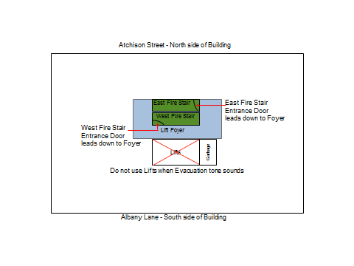

Garbage and Recycling

Each Level has a Garbage Recycling Room equipped with a Garbage Chute and two Recycling bins
- Garbage should be “double-bagged” and placed in the Garbage Chute. Please only use smaller supermarket plastic bags - larger bags will get stuck in the Garbage Chute
- At no time must the Garbage Chute be used for disposal of any loose items
- No liquids, sharp or irregular shaped items should be placed in the Garbage Chute as they will cause spillages, breakages and/or obstructions
- For any oversize bags - do not attempt to put these in the Garbage Chute. Take them directly to the Garbage room on Level M
- Recycled Paper and Cardboard should be broken down and placed in the Blue Bin
- Recycled Glass and Plastic should be placed in the Black Bin
- Please ﬂatten any cardboard boxes and cartons and take them to the Garbage room on Level M
- Bins are emptied daily and taken to the Garbage Recycling Room found on Level M
- If you have large quantities or bulky items of Glass, Plastic or Paper, please take them to the Garbage Recycling Room and breakdown into smaller pieces to place in the Recycling Bins
- Any larger items and any articles such as chairs, stools, pots, cupboards, carpets etc, MUST NOT be placed in the Garbage room or left on Common Property. The disposal of such items is the direct and personal responsibility of each resident. Two options are available:
  - Use the North Sydney Council Clean-up service which has 2 or 3 collections every month. Contact the council to arrange a booking, or
  - Take the items to the Artarmon Waste and Recycling Centre, Lanceley Place, Artarmon
- If you have any problems with Garbage, call the Building Manager (see page 2 for contact details)

Hot Water - Not Working?

Hot Water is supplied to each apartment from a central system located in the Level 12 Plant Room.
For Hot Water: A main Gas line rises up to Level 12 Plant Room and the Gas is used to heat the Hot Water (after it comes out of the Solar arrays). In each apartment, there is a Water meter (usually located in the laundry) on the Hot Water inlet that measures the amount of Hot Water used in an apartment. Hot Water usage data is collected from the Hot Water meter and sent to “your gas retailer” who does some fancy calculations and eventually you receive a Gas bill that includes a component for Hot Water.

For Cooking: A Gas meter (usually located somewhere in your kitchen) measures the amount of Gas you use for Cooking (usually a small amount) and the Gas meter is read electronically by “your Gas retailer” who adds this component to your Gas bill.

Therefore, each apartment needs to sign up with a “Gas retailer” and probably supply them with your address and maybe the “meter number” so that they can “virtually connect” you to the Gas supply.

Procedure for an apartment to use if:
There is no Hot Water in an individual apartment
- Call the Building Manager (see page 2 for contact details)

Intercom Operation

Each apartment has either a Video Intercom or an Audio Intercom that answers calls from the three main Residential entrances to Nexus:
- Atchison Street (adjacent to the glass sliding doors)
- Albany Lane (adjacent to the glass sliding doors
- Main Residential (adjacent to the glass Foyer doors)
- The Commercial entrance is not available for Residential access
- There are two types of Intercom units installed at Nexus:

- Video Intercom
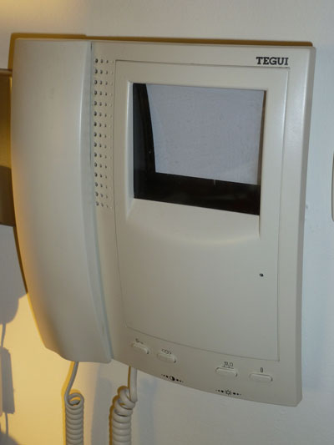
  - Some apartments have a Video Intercom with four buttons below the screen.
  - The first button (on the left) marked with the “key” symbol should be pressed when you have been called by a Visitor. This button will release or unlock the street entrance glass sliding doors and then a second call from the Residential entry will allow access through the glass Foyer doors to the Lift Lobby.
  - The second button (from the left) marked with the “<o>” symbol should be pressed to release or unlock the Lifts to allow access to your floor only.
  - The third and fourth buttons (from the left) are unused at Nexus.
  - In addition to these buttons, there are sliders located on the bottom of the Video unit that are used to control contrast and brightness of the viewing image.
- Audio Intercom
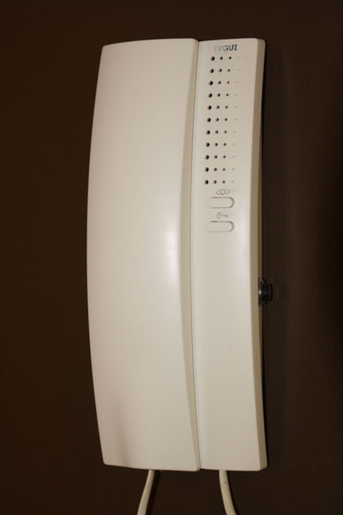
  - Some apartments have an Audio Intercom with three buttons and no screen.
  - The first button marked with the “<o>” symbol is not used at Nexus.
  - The second button marked with the “key” symbol should be pressed when you have been called by a Visitor. This button will release or unlock the street entrance glass sliding doors and then a second call from the Residential entry will allow access through the glass Foyer doors to the Lift Lobby.
  - The third button is the “black” button located on the right hand side of the Audio Intercom unit and should be pressed to release or unlock the Lifts to allow access to your floor only.

- There is a “preset time” (180 seconds i.e. 3 minutes) allowed between the Lift access button being pressed from an apartment and the Visitor pressing a Floor access button in the Lift. This time should be sufficient for a Visitor to walk through the Foyer, call a Lift, wait for its arrival and press your Floor access button.
- If multiple Visitors for different floors arrive during the same period, they should start their “own timer” and be able to access their selected floor.
- This all depends upon the appropriate button being pressed in the Resident apartment.
- If you have any problems with Intercom Operation, call the Building Manager (see page 2 for contact details).

Junk Mail

Each Mailbox has a NO JUNK MAIL sticker attached
- If you receive Junk Mail in your mailbox and do not require it, then dispose of it responsibly in the Recycling Bins
- Do not leave any Junk Mail on top of the mailboxes
- If you receive incorrectly addressed mail in your mailbox, then mark the mail as “Not known at this address - Return to Sender” and place it in a red Australia Post street mail box
- Do not leave any incorrectly addressed mail on top of the mailboxes as the Postman will not collect this mail for return
- It is estimated that each apartment receives 23 Kgs of Junk Mail per year which equates to 70 Kg CO2 emissions to produce, mail and dispose of. This much Junk Mail destroys 55 sqm of habitat and produces 100 litres of waste water per year!
- Your effort in keeping the mailbox area free of mess has helped reduce our Junk Mail by 99% and saves 2000 Kgs of Junk Mail per year passing through the Nexus recycling bins as well as reducing CO2 emissions by a massive 6.2 Tonnes per year!
- If you have any problems with Junk Mail, call the Building Manager (see page 2 for contact details)

Lift - Not Working?

Procedure for an apartment to use if:
A Lift is stuck for any reason
The number display on a Lift is not working
Someone is stuck in a Lift in an individual apartment
- Call the Building Manager (see page 2 for contact details) to call the Lift Company

Moving anything in or out or receiving a delivery?

The Lifts at Nexus service 88 apartments and as such are busy all day, every day
- All moving in or out of Nexus must be done between the hours of 09:00am to 02:00pm Monday to Friday and is not permitted on weekends, evenings or Public Holidays
- Please notify the Building Manager at least 48 hours prior to any move in or out so that the Lift can be booked and the Lift wall covers are fitted to avoid any damage
- A security deposit of $500 is to be left with the Building Manager before any move in or out is conducted. The deposit will be returned if there is no damage or cleaning costs incurred during the move in or out
- If any move in or out has to occur after the nominated times or days, please contact the Building Manager to make necessary arrangements. A call out fee of $200 will have to be paid to the Building Manager prior to any move in or out when the Building Manager is needed to attend after the nominated times or days
- Do not lean any heavy objects on walls or mirrors
- Close all doors held open after your move
- Do not leave any unwanted furniture in public areas or anywhere at the rear of the property
- Please clean up any spillages, mess or rubbish left behind after your move

Security Fob - Not Working?

Procedure for an apartment to use if:
An individual Security Fob is not working or is damaged
- Call the Building Manager (see page 2 for contact details)

Security System - Not Working?

Procedure for an apartment to use if:
The Security System is not working
- Call the Building Manager (see page 2 for contact details)

Smoke Detectors

Owners (and residents) are responsible for the operation, maintenance, repair and, where necessary, replacement of the apartment Smoke Detectors which exclusively services an apartment.
Each apartment is fitted with at least one HPM Cat 645/1Sl smoke detector/alarm by Law.

Operation
- The sensitivity of the smoke alarm is temporarily reduced by pressing the ‘Hush’ button on the smoke alarm cover. This silences the alarm, and replaces the alarm with a ‘chirp’ every 40 seconds. The alarm returns to full sensitivity after five minutes, and may sound the alarm if particles of combustion are still present. The ‘Hush feature may be used as frequently as required, until the air clears. However, before using this feature, identify the source of smoke and ensure that safe conditions exist.
- Test the alarm by pushing one unit’s test button for a few seconds. This should sound the alarm on all units if circuitry is active. If no alarm sounds, check the fusebox to make certain that the alarm is connected and active. Also check the back-up battery.
- To replace the 9 volt battery (the yellow LED will glow, and a chirping noise will emanate from the unit), slide the smoke-alarm unit to the side, in the direction of the arrow. It then unhinges from the baseplate, and can be removed if desired. The battery can be accessed without full removal from the hinge.

Telephone and Internet
Firstly, engage your telephone and/or Internet provider of choice (e.g. Telstra, Optus, TPG, etc) and sign all necessary contracts.

If the telecommunications service provider requires access to the Nexus MDF Room (only between the hours of: 09:00am to 02:00pm Monday to Friday, not permitted on weekends, evenings or Public Holidays), please have them contact the Building Manager (see page 2 for contact details) as the MDF Room requires a special access key.

Toilet/Sewerage - Not Working?

Procedure for an apartment to use if:
The toilet is not working in an individual apartment
- Call the Building Manager (see page 2 for contact details)

TV Reception - Not Working?

Procedure for an apartment to use if:
The TV reception is not working in an individual apartment
- Check that all TV connections are in place and connected to the wall socket (pictured below)
- Call the Building Manager (see page 2 for contact details)
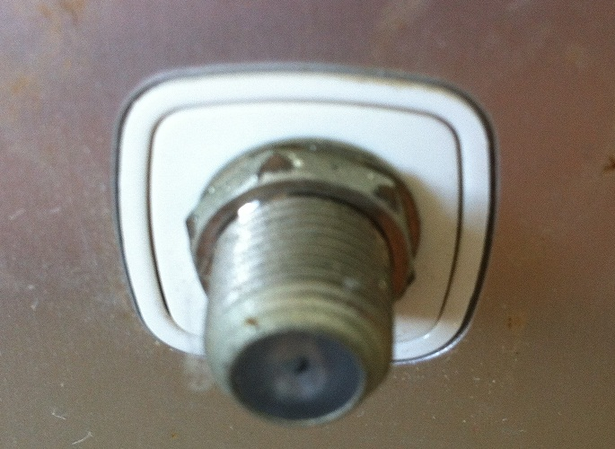

Utility Service Shutoff Points

Procedure for an apartment to use if:
It is necessary to shutoff services in an individual apartment
- Air Conditioning: Electrical shutoff at the Power Board in the apartment
- Electricity: Electrical shutoff at the Power Board in the apartment
- Gas: Main shutoff in the Kitchen cupboard adjacent to the stove in the apartment
- Water: Main shutoff in the Laundry cupboard in the apartment
- Telephone: Service connection via the MDF Room on Level M (Building Manager key access required)
- Call the Building Manager (see page 2 for contact details) for MDF Room access or any shutoff problems

Window Cleaning

External inaccessible windows are cleaned by the Body Corporate twice a year in June and December. Most windows are cleaned by abseiling from the roof, whilst some are cleaned by apartment access
If you have any problems with Window Cleaning, call the Building Manager (see page 2 for contact details)

Fire Control System

How does the Nexus Fire Control System notify an alarm?

- If smoke or fire (in any part of the Nexus building) is detected by the Nexus Fire Control System, an alarm is sent to the Fire Services Control Board on Level M and also to the Fire Brigade who are dispatched to Nexus
- An Evacuation alarm will then sound on the floor where the smoke or fire was detected as well as the floor above and below thus allowing two floors at a time to be evacuated and avoid a crush on the two sets of Fire Stairs. The process of sounding the alarm will then repeat itself two floors at a time to ensure an orderly exit from the building
- For example, if the smoke or fire is detected on Level 1, then the alarm sounds on Ground and Level 2, then after a period, on Level 3 and 4, then Level 5 and 6, etc until finally it sounds on level 10 and 11. If the sprinkler system had been activated (due to a fire), then the fire would have been extinguished on the initially detected level

What do you need to do when you hear an alarm and there is no apparent fire?

- If there is no smoke or fire in your apartment or immediate area, then;
- Follow all instructions given by the Intercom System
- Close all windows and doors in your apartment
- Feel the back of your entrance door to ensure that it is not hot (i.e. the fire is not on the other side of it)
- Leave immediately by the nearest safe exit and proceed down the Fire Stairs - do not use the Lifts
- Move quickly and do not run
- Close the Fire Stair doors behind you - do not prop them open as they will be pressurised by the Stair Pressurisation Fans
- Report to the designated assembly area across Atchison Street outside the Moody Chef Cafe - do not congregate in the Foyer or outside the front of the building as you could be hit by falling debris in the event of a major fire
- Advise a Warden or Fire Brigade member immediately if you are aware of any people trapped in the building
- Do not leave the assembly area until the Warden or Fire Brigade gives the "all-clear"

What do you need to do when you hear an alarm and there is fire or smoke?

- If there is smoke or fire in your apartment or immediate area, then;
- Call 000 (“triple zero”)
- Confine fire and smoke
- Close all windows and doors in your apartment
- Keep low, under the smoke
- Extinguish and control the fire (if safe to do so) - the Fire Sprinkler System would have activated in the event of fire and water would have extinguished the fire
- Leave immediately by the nearest safe exit and proceed down the Fire Stairs - do not use the Lifts
- Move quickly and do not run
- Close the Fire Stair doors behind you - do not prop them open as they will be pressurised by the Stair Pressurisation Fans
- Report to the designated assembly area across Atchison Street outside the Moody Chef Cafe - do not congregate in the Foyer or outside the front of the building as you could be hit by falling debris in the event of a major fire
- Advise a Warden or Fire Brigade member immediately if you are aware of any people trapped in the building
- Do not leave the assembly area until the Warden or Fire Brigade gives the "all-clear"

What do I do in an Emergency Evacuation?

Procedure to use if:
The Emergency Evacuation System is activated
- The Alert signal is to make you aware of an emergency situation and you should standby for the Evacuation tone or further verbal instructions
- The Evacuation tone signal is the signal for occupants to leave the building
- You should immediately leave the building via the Fire Stairs in a quiet and orderly fashion
- Report to the Assembly Point at the corner of Mitchell and Atchison Street outside Moody Chef Cafe
- Do not congregate in the foyer or at the front of building just in case there is a catastrophic disaster
- Wait for advice from the Fire Services to return to the building
- Call the Building Manager (see page 2 for contact details)

Safe Living in High Rise Buildings

Fire Services recommend this simple safety checklist for safe living in high rise buildings
- Each level of Nexus has firefighting equipment (fire hose reels) for residents to use in the case of fire. The fire hose reels are in the Fire Stairs
- The front door of your apartment is a certified fire resistant door. Making alterations to the front door can make it unsafe in the event of fire. Check with the Building Manager before making alterations
- Exit points are clearly identifiable by an illuminated green and white exit sign. Familiarise yourself with the exit points and where they lead
- Ensure your apartment has a suitable number of working smoke alarms installed. This required by law
- Develop a home escape plan from your apartment, and practice it regularly
- Never use a Lift in the case of a fire as they are not smoke or fire resistant
- Fire stairs provide a safe environment that will lead you to a safe place away from the building. Never chock open any fire stair doors as this will cause smoke and heat to enter the fire stairs
- Fire Stair doors and external apartment doors are designed to self close every time. Report any problems with these doors to the Building Manager immediately
- Never leave anything in a Fire Stair well at anytime!
- Never place burning or hot materials, flammable liquids or oily rags into the Garbage Chute
- Sprinkler heads should not be interfered with. Never hang anything (coat hangers included) off sprinkler heads. You and your furniture will get very wet!
- Damage to sprinkler heads, excessive smoke from the kitchen or steam from the bathroom are major causes of false alarms in residential high rise buildings, you may be charged $500 for the infringement and up to $130 for an administration fee

Fire Safety Tips

If you cannot escape by the Fire Stairs, do the following:
- Close all windows and doors to stop the smoke entering your apartment
- Call the Fire Services on 000 (“triple zero”) and tell them there is a fire in your apartment block. Tell them your apartment number and that you are unable to get out of your apartment safely, and then follow any advice given to you by the Fire Service

